ANYKŠČIAI PUBLIC ENTERPRISE „SVEIKATOS OAZĖ“
LITHUANIAN SWIMMING FEDERATION

INTERNATIONAL SWIMMING SPRINT FESTIVAL
„Anykščiai – 2013“

INVITATION

Anykščiai public enterprise „Sveikatos oazė“ and Lithuanian Swimming Federation invite Estonian swimming club TOP and ESS “Kalev” team to the 15th anniversary International Swimming Sprint Festival „Anykščiai – 2013“ held on 2-4 May 2013 in Anykščiai.
Organizers expect this anniversary festival to reflect all former International Swimming Sprint Festivals and to be remarkable and memorable to its participats, guests and fans.
Organizers are proud of rich history of the festivals „Anykščiai“ and participation of such swimming sport stars: Olympic champion Rūta Meilutytė (Lithuania), World and European champion, vice-champion of the Olympic Games Aliaksandra Herasimenia (Belarus), bronze medal winner at the World Swimming Championship, 8 place winner at the London Olympic Games Giedrius Titenis (Lithuania), medal winners at European swimming championships Svetlana Hahlova (Belarus), Vytautas Janušaitis, Saulius Binevičius (Lithuania), festival record holders of all age groups and each participant.
This festival is dedicated to celebrate the 20th anniversary of Anykščiai swimming pool „Bangenis“ and will be represented by one of the best Lithuanian swimmers Giedrius Titenis. All festival events, including swimming competition, celebratory opening event, cultural program and evening event will be held in one place – at the swimming pool. Winners and prize winners of the competition will receive medals, specially made for this anniversary. Absolute winners will be announced for each age group.
Good athmosphere at the swimming pool will be assured by its talisman the Frog as well as dance performances, good music. Sweets with sponsors and organizers’ logos will be specially made for the festival. Final swimmings will be aired online at sportTv.lt. Information and news about the festival in Lithuanian and English can be found at http://www.sveikatosoaze.lt/festivalis/.
Organizers invite 25 members of your team (including coaches and other members of the delegation) to participate and compete in the International Swimming Sprint Festival „Anykščiai – 2013“, meet friends and colleagues and celebrate the 20th anniversary of the swimming pool „Bangenis“.
We kindly ask you to confirm your participation by sending us the entry till 23 April, 2013.
We are expecting you!

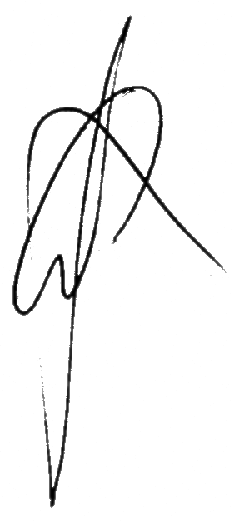
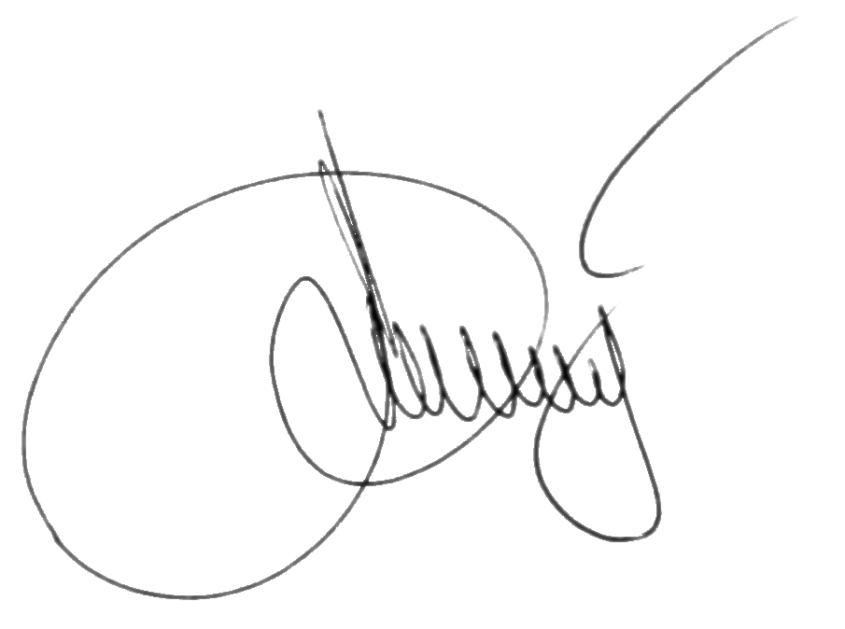
Head of PE „Sveikatos oazė“ Sonata Veršelienė

Head of the Festival Audronius Gališanka

Our addresses:
Public Enterprise "Sveikatos oazė" Lithuanian Swimming Federation
Ažupiečių Str. LT-29148 1A, Anykščiai, Lithuania Žemaitės Str. 6, LT-03117, Vilnius, Lithuania Tel/fax: +370 381 59 431 Tel/fax: + 370 52339288
E-mail: sveikatosoaze@res.lt E-mail: gintasbar@gmail.com
www.sveikatosoaze.lt

INTERNATIONAL SWIMMING SPRINT FESTIVAL “ANYKŠČIAI-2013”
REGULATIONS

- Swimming competition is held on 2-4 May 2013 in Anykščiai 25 m and 6 lane swimming pool, applying electronic time system.
- Competition is included in the European swimming federation calendar of international competitions of 2013 and is held under FINA rules.
- Participants of the competition are: invited swimming clubs and sport schools‘ teams and swimmers, whose entries were received until the indicated date. Number of participants is limited and organizers keep the right not to accept, informing about it beforehand, entries from independently registered teams.
- Entries for participation in the festival shall be sent to the referee of the competition by email gintasbar@gmail.com and to the public enterprise by email sveikatosoaze@res.lt. Technical entries or any amendments shall be sent to the referee by email gintasbar@gmail.com till 23 April 2013. Amendments are accepted till 10 a.m., 2 May, 2013. Belated entries or amendments are not accepted.
- Nominal entries together with medical visas shall be presented to the head secretary of the competition till 9.00 a.m, 3 May 2013. Each participant shall have doctor’s permission to participate in the competition. Leader of the participating team is responsible its members have it.
- Competition is personal and team points are not counted.
- One participant can compete in one age group. Number of starts for the participants is unlimited.
- Team of 15 or more participants (swimmers) must participate in the relay (7x50 m Freestyle).
- Start fee is 15 LTL per start and 25 LTL per team‘s participation in the relay.
- The number of participants is limited to 500 (with the exception of veteran and disabled groups). All entries of invited or independently registered teams will be registered. Teams which have indicated higher number of the participants in the entry than it was indicated in the invitation as well as independently registered teams or participants shall be allowed to participate in the festival as it is indicated in their entries only in case the number of participants do not exceed the limit or any of the invited teams refuse to participate.
- Each participant will receive memory gift with festival symbols.
- All expenses related to the participation in the festival shall be covered by the sending organization or participants individually. Arrivals are up to 8.00 a.m.,3 May 2013.
- Age groups:
I – girls and boys, born in 2000 and younger;
II – boys, born in 1998-99;
III – girls, born in 1998-99 and boys, born in 1996-97
IV – women, born in 1997 and older and men born in 1995 and older;
V - Veterans: men and women up to 35 years old. Participants of this age group shall have finished their sport career not prior to 2 years, this means they haven‘t participated in professional swimming championships in their countries for 2 years.
VI – Disabled: men and women. Number of participants in this age group in unlimited.

Events:

3 May (Friday)
Event | Age group
100 m Freestyle | V a.g. women
50 m Butterfly | V a.g. men
100 m Freestyle | I – IV a. g.
50 m Backstroke | I – IV a. g.
100 m Butterfly | I – IV a. g.
50 m Breastroke | I – IV a. g.
100 m Medley | I – IV a. g.

4 May (Saturday)
Event | Age group
100 m Freestyle | VI a.g. men and women
50 m Backstroke | V a.g. women
100 m Freestyle | V a.g. men
100 m Breastroke | I – IV a. g.
50 m Butterfly | I – IV a. g.
100 m Backstroke | I – IV a. g.
50 m Freestyle | I – IV a. g.
Relay 7x50 m Freestyle | One participant of each age group I – IV

- Awards.
Winners and prize winners of each event (of all age groups) are awarded with special anniversary medals and diplomas, 4-6 places winners - with diplomas. Team winner of 7x50 m Freestyle relay is awarded with cup.
3 best female and 3 best male swimmers (based on FINA point calculation table) of I- III age groups
are awarded with special prizes and 3 best female and 3 best male swimmers of IV age group are awarded with money prizes: I place – 1000 LTL, II place – 750 LTL, II place – 500 LTL. Festival‘s record holders are awarded with special prizes. Organizers may set other prizes and inform about it before the event.
.

Training, catering and accommodation conditions:
Accommodation is offered for the team from Estonia swimming club TOP and ESS “Kalev” for
25 people at hotel of “Nykščio namas”
Price per person per day – 76,50 LTL. (breakfast included).

More information about accommodation:

Upon your request organizers can book catering at the accommodation place or elsewhere in Anykščiai (the request shall be noted in the entry).

Training times at the swimming pool on 2 May shall be coordinated beforehand by phone (+370 381) 517 55, (+370 381) 5 94 31, fax (+370 381) 59431 or email sveikatosoaze@res.lt.

International Swimming Sprint Festival „Anykščiai – 2013“
Program
2 May (Thursday)
Anykščiai swimming pool „Bangenis“

12 a.m. – 10 p.m. Registration. Trainings.

3 May (Friday)
Anykščiai swimming pool „Bangenis“

8.30 a.m. Teams‘leaders meeting
9.00 - 9.20 a.m. Warm up /IV and V age groups/
9.30 - 10.25 a.m. Heats /IV and V age groups/
10.25 - 10.45 a.m. Warm up /III age group/
10.50 - 11.50 a.m. Heats /III age group/
11.50 – 12.10 a.m. Warm up /II ir I age group/
12.15 - 2.10 p.m. Heats /II and I age groups/
2.10 - 4.00 p.m. Break
4.00 – 4.45 p.m. Celebratory opening of the festival. Cultural program.
4.45 p.m. Warm up for finalists
5.30 p.m. Finals
8.00 – 10.00 p.m. Evening event (Party).

4 May (Saturday)
Anykščiai swimming pool „Bangenis“

8.30 - 9.00 a.m. Warm up /IV, V and VI age groups/
9.05 - 10.00 a.m. Heats /IV, V and VI age groups/
10.05 - 10.25 a.m. Warm up /III age groups/
10.30 - 11.25 a.m. Heats /III age group/
11.30 - 11.50 a.m. Warm up /II and I age group/
11.55 - 1.05 p.m. Heats /II ir I age group/
1.05 - 3.15 p.m. Break
3.15 p.m. Warm up for finalists
4.00 p.m. Finals
6.30 p.m. Best swimmers awards. Festival closing.

Referee of the International Swimming Sprint Festival Gintautas Bartkus
„Anykščiai – 2013”

Chief Judge of the International Swimming Sprint Festival Žilvinas Ovsiukas
„Anykščiai – 2013“

N.B.Organizers keep the right to change the timings of the competition.

We are expecting you in Anykščiai!

ENTRY

FOR PARTICIPATION IN THE INTERNATIONAL SWIMMING SPRINT FESTIVAL „ANYKŠČIAI-2013”

Team name

________________________________________________________________________

Team leader’s name and surname

________________________________________________________________________

Telephone, fax, e-mail

Participants: _____swimmers, _____leaders, coaches.

Accommodation needed for ____people, _____of them women and _____ men.

Catering needed for _____ people.

Desirable catering place: _______________________________________________

Arrival ___ May, 2013. Departure ___ May, 2013.
Short team description (2 or 3 sakiniais)______________________________________________________________________________________________________________________________________________________________________________________________________________________________________________________________

_______________ ______________
(Name, surname) (Signature)

Please send the entry until 23 April, 2013 to the Lithuanian Swimming Federation by email gintasbar@gmail.com or by fax (+370~5) 2339288 and to the Public Enterprise „Sveikatos oazė“ by email sveikatosoaze@res.lt or by fax (+370 381) 59431

We are expecting you in Anykščiai!

INTERNATIONAL SWIMMING SPRINT FESTIVAL „ANYKŠČIAI“
WOMEN’S RECORDS

Event | Age Gr. | Name, Surname | Club | Result | Year
100 m Freestyle | 1st | Vaiva Gimbutytė | Kaunas SS „Šilainiai“ | 59,82 | 2008
100 m Freestyle | 3rd | Jūratė Ladavičiūtė | Panevėžys SS„Žemyna“ | 0.57,75 | 1999
100 m Freestyle | 4th | Svitlana Khakhlova | Belarus | 0.55,54 | 2003
50 m Backstroke | 1st | Nika Korbane | Liepoja SC | 0.31,31 | 2011
50 m Backstroke | 3rd | Asta Drevinskaitė | Kaunas SS „Vilija“ | 0.30,40 | 2010
50 m Backstroke | 4th | Alexandra Bas | Belarus | 0.28,85 | 2003
100 m Butterfly | 1st | Vaiva Gimbutytė | Kaunas SS „Šilainiai“ | 1.07,25 | 2008
100 m Butterfly | 3rd | Giedrė Grigonytė | Vilnius SC „Lugnynė“ | 0.28,40 | 2010
100 m Butterfly | 4th | Giedrė Grigonytė | Vilnius SC„Lugnynė“ | 1.00,77 | 2011
50 m Breaststroke | 1st | Dana Kolidzeja | Ryga SC „Daugava“ | 0.34,45 | 2012
50 m Breaststroke | 3rd | Alena Aliaksandrovich | Minsk SK “Start” | 0.32,80 | 2006
50 m Breaststroke | 4th | Svitlana Khakhlova | Belarus | 0.32,14 | 2005
100 m Individual Medley | 1st | Jasoda Jessa | SK “Slowia”, Poland | 1.10,31 | 2007
100 m Individual Medley | 3rd | Giedrė Grigonytė | Vilnius SS„Lugnynė“ | 1.04,93 | 2010
100 m Individual Medley | 4th | Svitlana Khakhlova | Belarus | 1.03,21 | 2003
100 m. Breaststroke | 1st | Rūta Meilutytė | Kaunas SS „Šilainiai“ | 1.10,64 | 2010
100 m. Breaststroke | 3rd | Alena Aliaksandrovich | Minsk SK “Start” | 1.11,91 | 2006
100 m. Breaststroke | 4th | Erika Bespalko | Kauno SS “Centras” | 1.09,25 | 2009
50 m Butterfly | 1st | Giedrė Grigonytė | Vilnius SC „Lugninė“ | 0.29,25 | 2008
50 m Butterfly | 3rd | Kseniya Lebedzeva | Minsk SK “Start” | 0.28,77 | 2006
50 m Butterfly | 4th | Svitlana Khakhlova | Belarus | 0.27,36 | 2005
100 m Backstroke | 1st | Ugnė Mažutaitytė | Kaunas SS „Dainava“ | 1.07,65 | 2010
100 m Backstroke | 3rd | Nadzeya Hancharyk | Minsk SK „Jantar“ | 1.03,87 | 2006
100 m Backstroke | 4th | Alexandra Bas | Belarus | 1.01,39 | 2007
50 m Freestyle | 1st | Rūta Meilutytė | Kaunas SS „Šilainiai“ | 0.26,61 | 2010
50 m Freestyle | 3rd | Giedrė Grigonytė | Vilnius SK „Lugnynė“ | 0.26,46 | 2010
50 m Freestyle | 4th | Aliaksandra Herasimenia | Belarus | 0.24,85 | 2003
Relay 7x50 m  Freestyle | Mixed | Herman Aadamsoo  Karleen Kepsa  Pjotr Degtjarjov  Katriin Kepsa  Lauri Kai  Katlin Sepp  Herol Marjak | TOP SC Tallin | 3.04,76 | 2008

INTERNATIONAL SWIMMING SPRINT FESTIVAL „ANYKŠČIAI“
MEN’S RECORDS
Event | Age Gr. | Name, Surname | Club | Result | Year
100 m Freestyle | 1st | Mateusz Maksimowicz | SK “Slowia”, Poland | 0.58,11 | 2007
100 m Freestyle | 2nd | Povilas Strazdas | Vilnius SC | 0.52,35 | 2011
100 m Freestyle | 3rd | Danas Rapšys | Panevėžys SS „Žemyna“ | 0.50,18 | 2012
100 m Freestyle | 4th | Saulius Binevičius | Kaunas SC „Orka“ | 0.48,56 | 2004
50 m Backstroke | 1st | Janis Saltans | Riga SK„Kipsala“ | 0.30,14 | 2009
50 m Backstroke | 2nd | Janis Saltans | Ryga SK „Kipsala“ | 0.26,90 | 2011
50 m Backstroke | 3rd | Janis Šaltans | Riga SC „Kipsala“ | 0.25,82 | 2012
50 m Backstroke | 4th | Darius Grigalionis | Panevėžys SS „Žemyna“ | 0.24,43 | 2004
100 m Butterfly | 1st | Arkadi Kalinovski | Tallinn SC „Aktiv“ | 1.03,29 | 2009
100 m Butterfly | 2nd | Deividas Čepulis | Šiauliai SS „Delfinas“ | 0.58,57 | 2004
100 m Butterfly | 3rd | Rimvydas Šalčius | Kaunas SS „Šilainiai“ | 0.54,37 | 2002
100 m Butterfly | 4th | Rimvydas Šalčius | Kaunas SS „Šilainiai“ | 0.53,27 | 2003
50 m Breaststroke | 1st | Mantas Budrys | Kaunas SS „Vilija“ | 0.32,76 | 2010
50 m Breaststroke | 2nd | Ramman Karolik | Minsk „COCR“ | 0.30,29 | 2010
50 m Breaststroke | 3rd | Vaidotas Blažys | Kaunas SS „Dainava“ | 0.28,35 | 2009
50 m Breaststroke | 4th | Edvinas Dautartas | Kaunas SS „Vilija“ | 0.28,39 | 2008
100 m  Individual Medley | 1st | Dmitrij Sunusins | Ryga SC „Delfin“ Latvia | 1.05,74 | 2009
100 m  Individual Medley | 2nd | Povilas Strazdas | Vilnius SC | 0.59,96 | 2011
100 m  Individual Medley | 3rd | Antons Voitovs | Ryga SC „Delfin“ | 0.58,14 | 2011
100 m  Individual Medley | 4th | Vytautas Janušaitis | Kaunas SS „Vilija“ | 0.54,32 | 2009
100 m Breaststroke | 1st | Anton Adamenia | Gardin SS, Belarus | 1.10,22 | 2009
100 m Breaststroke | 2nd | Anton Adamenia | Gardin SC | 1.06,04 | 2011
100 m Breaststroke | 3rd | Aurimas Valaitis | Kaunas CSS | 1.02,17 | 2005
100 m Breaststroke | 4th | Edvinas Dautartas | Kauno SS „Vilija“ | 0.58,73 | 2009
50 m Butterfly | 1st | Jevgenij Rogozin | Vilnius WSS | 0.27,90 | 2009
50 m Butterfly | 2nd | Yahor Dodaleu | Minsk SK „Start“ | 0.24,88 | 2010
50 m Butterfly | 3rd | Rimvydas Šalčius | Kaunas SS „Šilainiai“ | 0.25,21 | 2002
50 m Butterfly | 4th | Romans Miloslavskis | Liepaja SS, Latvija | 0.24,15 | 2009
100 m Backstroke | 1st | Janis Saltans | Ryga SC „Kipsala“ | 1.02,80 | 2009
100 m Backstroke | 2nd | Janis Saltans | Ryga SC „Kipsala“ | 0.56,95 | 2011
100 m Backstroke | 3rd | Viktar Staselovich | Minsk SC „Start“ | 0.56,05 | 2011
100 m Backstroke | 4th | Vytautas Janušaitis | Kaunas SS „Vilija“ | 0.52,84 | 2008
50 m Freestyle | 1st | Janis Saltans | Riga SC „Kipsala“,Latvia | 0.26,20 | 2009
50 m Freestyle | 2nd | Janis Saltans | Ryga SC „Kipsala“ | 0.23,87 | 2011
50 m Freestyle | 3rd | Danas Rapšys | Panevėžys SC „Žemyna“ | 0.23,24 | 2012
50 m Freestyle | 4th | Rolandas Gimbutis | Kaunas SC „Orka“ | 0.22,66 | 2001

